Online Shopping:

This Example is design for beginners/ learners in Software test.

The entire scenarios is to carry a Manual test. In this Example i have given a sample IEEE TEST PLAN , Test Scenarios, Test Cases. This how, we will be doing in our real time scenario.

I have also included some use full Diagrams which will gives you a clear understanding of this Application which is to be Test. Here I'm will not included Bugs and Bugs report so its going to give you a wider understanding of test cases and test scenario. You can use this same format to practice any web applications.

The project is just simple Web shopping, where a customer can Search, shop, Register, Cancel item, add Items, Pay.

USE CASE:-

Customers

**Preconditions:**

Customer must have a valid user ID.

**Normal flow of events:**

Log in.

View and edit Own Details

Choosing and comparing products

Purchasing

Logout

**Alternate flow of events:**

New customer registration

Complaining to Customer Care

**Post Condition**:

A happy Customer

Following diagram will give the complete flow action of a Customer.

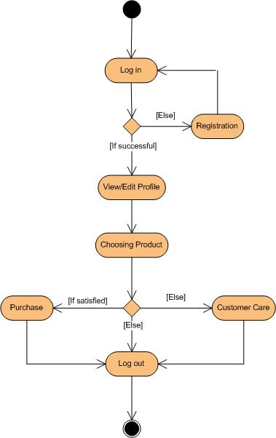

Visitors

**Preconditions:**

Administrator is already logged in.

Normal flow of events:Visiting the Site

Alternate flow of events: None.

**Post Condition:**

Proper separation between customers and window-shoppers.

Vendor

**Preconditions:**

Can consult with the Administrator regarding product’s quality and advertisements.

Normal flow of events: Can consult with the Administrator regarding product’s quality and advertisements.

Alternate flow of events: Can leave the project.

Post Condition:

Various attractive items for customers.

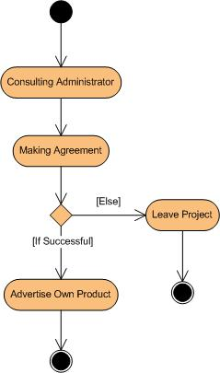

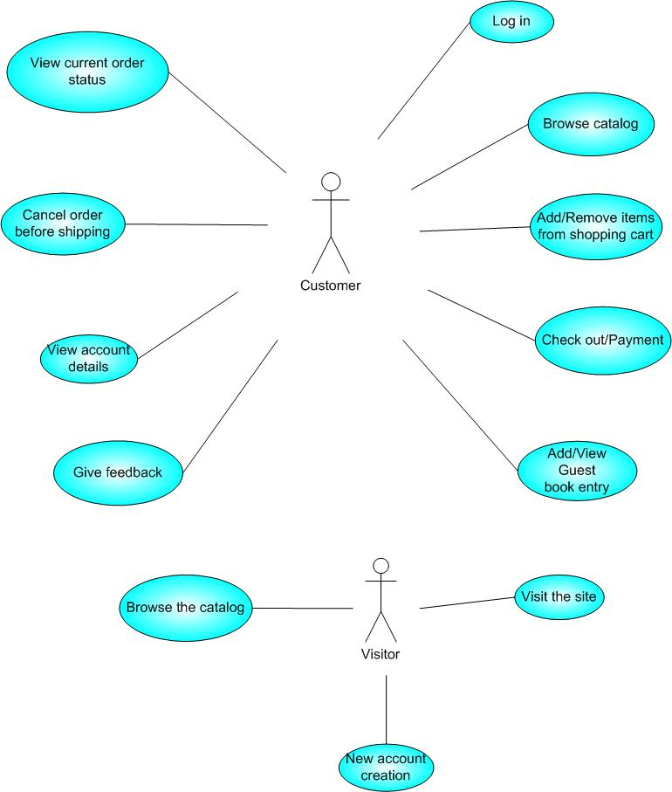

Figure : Use case diagram for Customer & Visitor

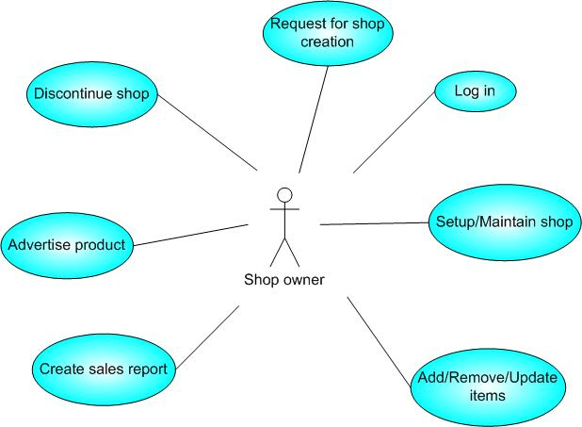

Figure : Use case diagram for Shop owner

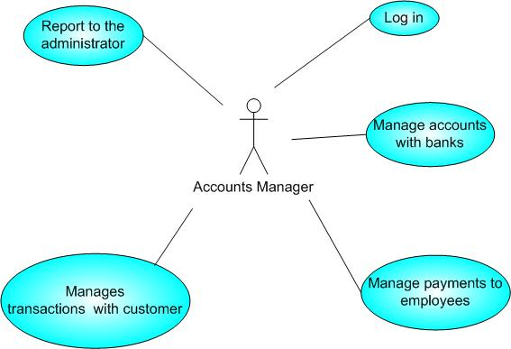 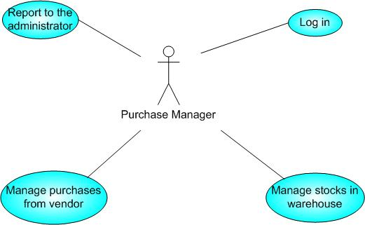

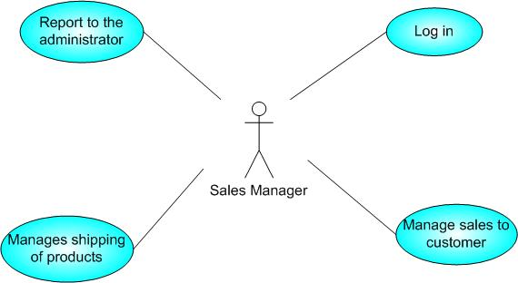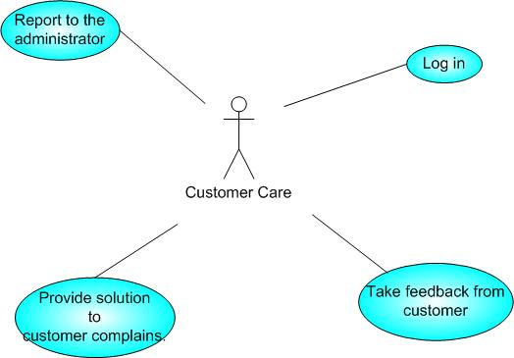

Figure : Use case diagram for Employees

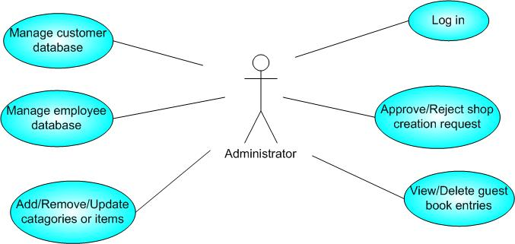

Figure : Use case diagram for Administrator